SHAPE DEMO(3/11/25)
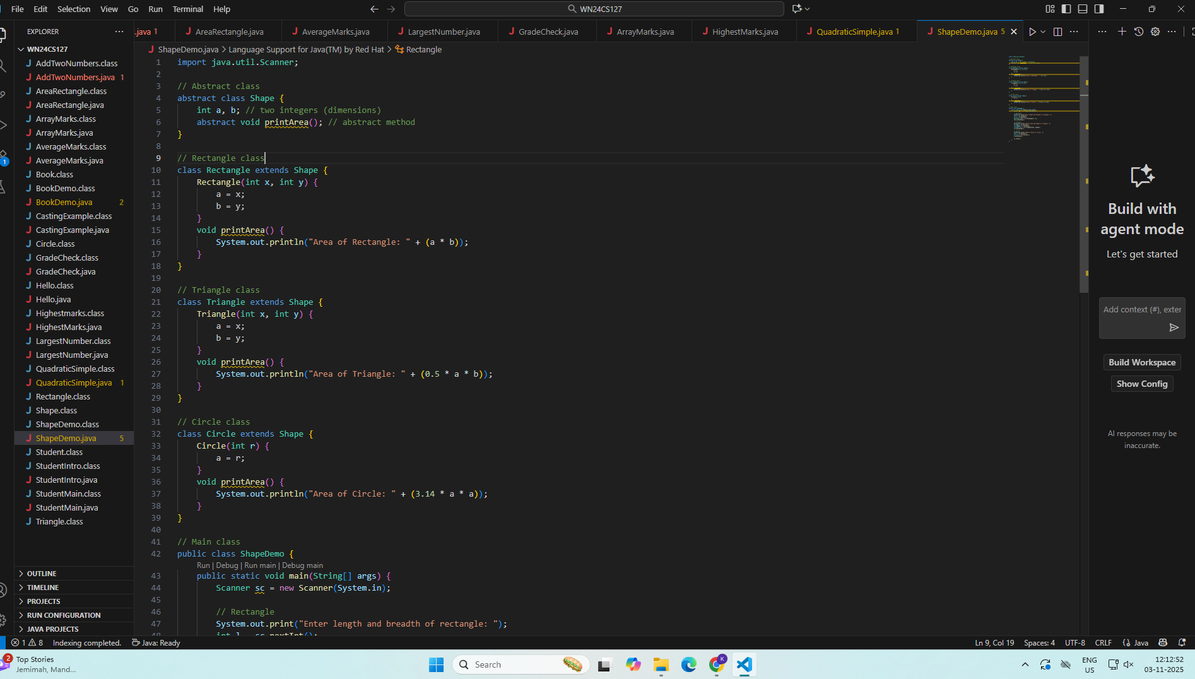
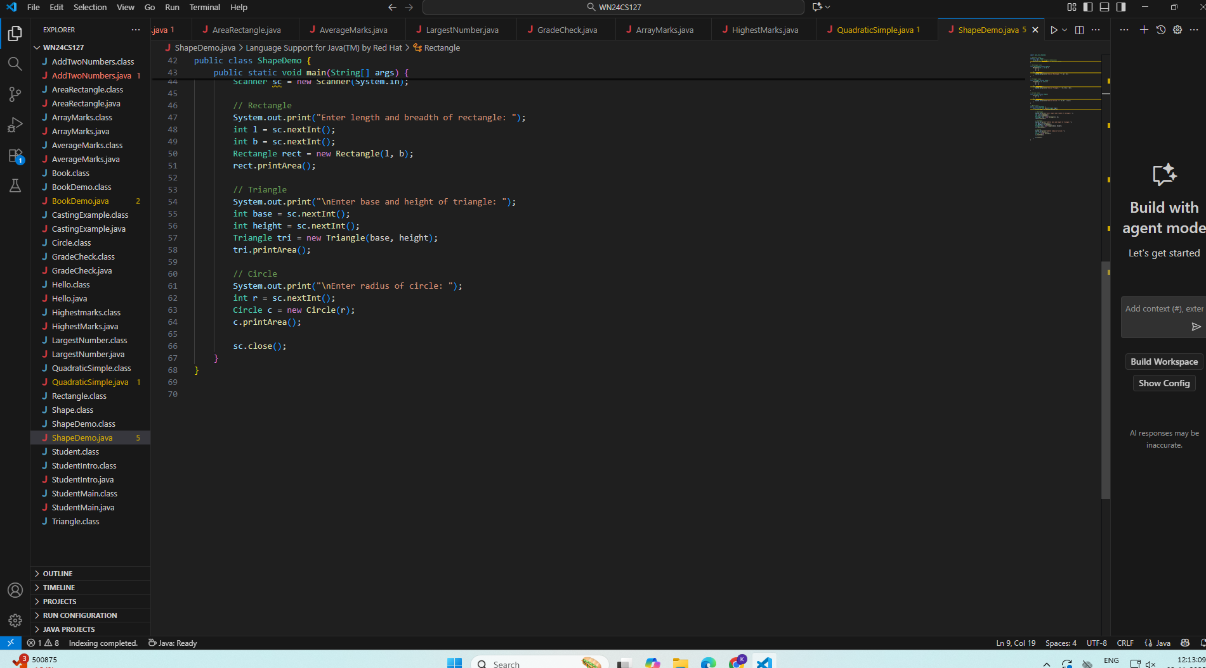
OUTPUT:
K ABHIRAMA PURANIKA(1WN24CS127)

